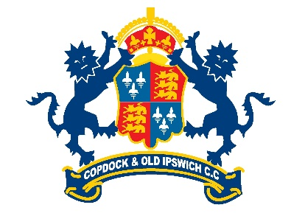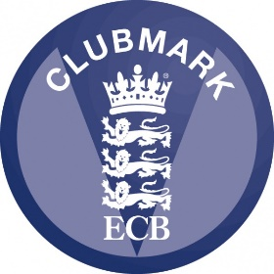

CODE OF CONDUCT - JUNIOR MEMBERS

In order to ensure everyone has an enjoyable time at Copdock and Old Ipswichian Cricket Club there are a few rules that junior members are asked to stick to, this is the player’s code of conduct.

Kids zone aims to ensure all player’s of mixed ability can enjoy cricket within a safe environment.

We say:
- KIDS are Nr 1
- HAVE FUN winning is not everything
- COACHES coach
- PLEASE DO NOT shout in anger
- ABUSE in any form, either verbal, physical or racial is not acceptable
- PLEASE put your litter in the bin or take it home
- SWEARING is not permitted
- RESECT the coaches, umpire and other helpers
- BE PROUD of your club and act in a responsible way when representing Copdock in matches

Copdock Cricket Club is fully committed to safeguarding and promoting the well-being of all its members. The club believes that it is important that members, coaches, administrators and parents associated with the club should, at all times, show respect and understanding for the safety welfare of others. Therefore, members are encouraged to be open at all times and to share any concerns or complaints that they may have about any aspect of the club with Nick Meakin, Kathy Stanes and Angus Watson our Club Welfare Officers.

As a member of Copdock Cricket Club you are expected to abide by the following:
- All members must play within the rules and respect officials and their decisions.
- All members must respect the rights, dignity and worth of all participants regardless of gender, ability, cultural background or religion.
- Members should keep to agreed timings for training and matches or inform their coach/match manager if they are going to be late.

Members must wear suitable kit:
- When batting, pads, box, gloves and helmet
- When fielding wicket keeper, pads, gloves and helmet
- For training and match sessions, as agreed with the coach/match manager.
- Members must pay any fees for training or events promptly.
- Junior members are not allowed to smoke on club premises or whilst representing the club.
- Junior members are not allowed to consume alcohol or drugs of any kind on Club premises or whilst representing the club.

